**GARSTANG ST THOMAS**

**Church of England Primary School**

**Home/School Agreement**

Dear Parents,

I am pleased to present our home/school agreement. Please discuss the agreement with your child, sign it with them and/or on their behalf and return it to school.

Thank you,

Mr J Blakely

Head Teacher

________________________________________________________________________________________________________

**Our School**

Garstang St Thomas’ Primary School has an “open door” policy towards parents and friends of the school. Please do not hesitate to call us at the school if there is anything we can do to help with regard to your child and their education.

The school prospectus is available from the main school office or on our website at:

**http://www.garstangstthomas.com/admissions/**

**Wrap Around Care**

The school offers a breakfast club from 7.30am and an after school club, After School Club until 5.45pm on school days. Parents wishing to book these should speak to the school office on 01995 603454.

**Our School Vision**

Our vision is to be an excellent Church of England school which is forward thinking and strives for continual development.

We seek to support all our children in knowing that they are loved by God and encourage them in reaching their full potential academically, physically and spiritually.

We seek to develop in our children a great love of learning and for them to become confident, resilient, independent, inquisitive individuals who are able to both lead and serve others joyfully.

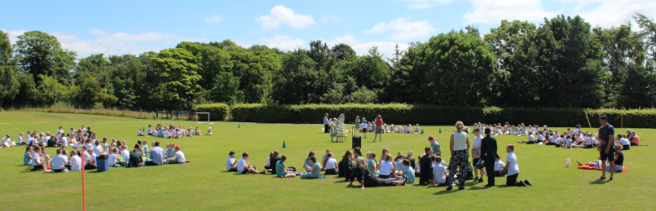**The school will:**

• Work to fulfil the mission statement.

• Encourage children to do their best at all times.

• Encourage children to take care of their

surroundings and others around them.

• Let parents know about any concerns or problems

that affect their child’s work or behaviour.

• Set, mark and monitor homework

• Send home an annual pupil progress report.

• Arrange two Parents’ Evenings (in the Autumn and Spring Terms) during which progress

will be discussed.

• Keep parents informed about school activities through regular communication, newsletters on

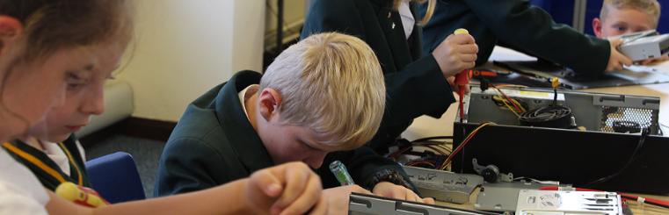the school website and notices about special events.

• Support and reinforce safe road user behaviour.

• Support and reinforce safe online behaviour.

**The family will:**

• Support the school’s vision and educational aims.

• Make sure their child arrives at school on time and wearing the correct school uniform.

• Ensure their child attends school regularly and provide a written or telephone explanation on

the first day of absence.

• Let the school know of any concerns or problems that might affect the child’s work or behaviour.

• Support the child in homework and in other opportunities for home learning.

• Seek permission from the Head Teacher if it is necessary to take their child out of school for holidays.

• Attend Parents’ evenings and discussions about their child’s progress.

• Ensure their child takes care on the road, getting in and out of vehicles in appropriate

places, complying with parking restrictions such as zigzag markings.

• Ensure their child is safe online.

• Get to know about their child’s life at school.

**As a pupil I will:**

• Stick to school values.

• Be kind, friendly and polite to others.

• Take care of everything in school.

• Walk inside the building.

• Talk quietly and be silent when asked.

• Always try my best and ask if I do not understand.

• Make sure that I take letters from school home.

• Complete my homework.

• Make sure I am careful and act sensibly at the school crossing taking notice of the School Crossing Patrol.

• Take care getting in and out of cars and be thoughtful when on or near roads.

• Follow the school’s online safety rules when using the internet.

(SignedParent/Carer)…………………………………………………….(Date)…………………………………………….

(Signed Child)……………………………………………………..............(Date)…………………………………………….

(Signed on behalf of the school)……………………………………… (Date)…………………………………………….